2013 (the Ninth)
International Seminar & Exhibition for China Distributed Energy
——Promote the Diversified Development
New Mindset ∙ New Technology ∙ New Model of Distributed Energy

Sponsors: Chinese Society for Electrical Engineering
China City Gas Association
China Society of Biogas
China Society of Renewable Energies
State Regional Energy Specialty Committee
China Energy Net

Co-Organizer: The Distributed Energy Specialty Committee of China
Energy Research Association
The Distributed Energy Specialty Committee of China
City Gas Association

Cooperation Partners: American Gas Technology Institute
Sino-US Energy Cooperation Project

August, 2013. Beijing
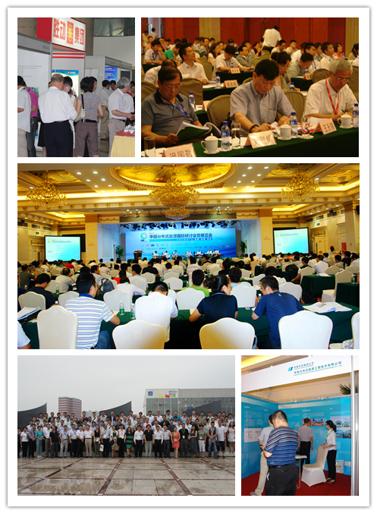
Introduction of the Seminar & Exhibition
Through eight years` relentless innovation and self-improvements, the International Seminar & Exhibition of China Distributed Energy has become the seminar that bears the most significant influence in its kind in the industry and the display platform for precise and in-depth marketing. Since the last seminar held in 2012, 319 guests from 156 businesses and agencies have convened in Changsha discussing the development and cooperation of the industry.
This seminar is aimed to promote in-depth exchange from perspectives of policy, production, studying, researching, and application to make due contribution to the scientific and orderly development of the distributed energy industry.
Why US?
- Old Name Brand > Deserves Your Dependence
2012 (the Eighth) International Seminar & Exhibition of China Distributed Energy Changsha Visit “Huang Hua International Airport T2 Terminal Building”
2011 (the Seventh) International Seminar & Exhibition of China Distributed Energy Qingdao Visit “Qingdao Waste Water Power Generation Project”
2010 (the Sixth) International Seminar & Exhibition of China Distributed Energy Shanghai Visit “the Project for World Expo”
For details please go to：http://www.china5e.com/html/old_special_html/special_587.html
- High Quality > Word of Mouth Advertising
Sponsored by the six largest professional agencies, a get-together party for the heavy-weighted experts in the industry and the leaders of the businesses in the chain of the industry, for discussion and researching of the contents that lead to the new trends of development of the industry.
High-end seminar influences high-end group of people, there`s no form of business that is more efficient than face-to-face communication among the high level of executives and managements, and the seminar of each of the sessions has attracted more and new friends to the circle.
- Share Project > Fruitful Harvest
Visit to the typical distributed energy project has been arranged for the seminar of each session. On-site visit shall be arranged to the projects typical in the three regions of Beijing, Tianjin and Hebei Province for the coming seminar during which, first-handed systematic information shall be obtained on site and the experiences from couple of actual cases shall be shared.

Seminar Background
According to the <<Twelfth Five-Year Plan for Energy Development>>, China shall have built, by year 2015, 1000 natural gas “Distributed” energy projects, 10 demonstration communities of natural gas distributed energy, 10,000 MW of distributed solar power generation facilities, and 100 demonstration cities of new energies dominated by distributed renewable energy. Developing the power generation by means of photovoltaic, wind, and natural gas in distributed way has become an important element of the energy strategy for each of the countries in the world when it comes to dealing with climate change and securing energy safety; and active development of distributed energy bears significant meanings for optimizing energy structure, promoting energy saving and emission reduction, and reducing PM 2.5 effectively from electric power industry. It is doubtless that, along with the fact that distributed energy has been moved onto the fast track for growth and with the elimination of interconnection restrictions, the spring for distributed energy has arrived, though certain policies are to be elaborated in details.

Facing the new situations and new challenges, diversified development of distributed energy is urgent and necessary, and proposing of new mindset, application of new technology, and generalization of new model are imperative. Under such a background, the authoritative and high-end brand seminar in distributed energy field – 2013 (the Ninth) International Seminar & Exhibition of China Distributed Energy is coming soon. The seminar shall be jointly sponsored by the China Energy Net, the entity that paid the earliest attention to the domestic distributed energy field, together with China Society of Electrical Engineering, China City Gas Association, China Society of Biogas, China Society of Renewable Energies, etc. with the aims of exploring the diversified development of distributed energy in the form that combines researching, studying, exhibition and project visit so as to promote application of new mindset, new technology, and new model in the industry. It is believed that, through joint participation and cooperation by all the parties, more effective distributed energy projects will be built to better the harmonious development of environment and society.

Participants:

- Governmental Agencies  - Associations and Societies  - Gas Companies  - Electric Power Businesses  - Energy Service Providers | - Equipment Suppliers  - Grid Companies  - New Energy Businesses  - Investing and Financing Institutions  - Scientific Research Agencies

Proposed Agenda

Day One Beijing  Morning: Promote Diversified Development • New  Mindset of Distributed Energy  Market Analysis and Prospect of the Distributed Energy  under the New Interconnection Policy  How to Promote Building of the System of Standards for the Distributed Energy  The Opportunities and Challenges Faced by the Demonstration Cities and Industrial Parks  A Simple Analysis on the <<Opinions on Advancing the Interconnection Service Work for Distributed Energy>>  The Current Situations of the Distributed Energy in Abroad  The Impact of the Third Industrial Revolution to Energy Industry  The Role of the Distributed Energy in the Urbanization  Zhou Xiaoxin - Academician, Chinese Academy of Sciences; Academician of IEEE  Hu Weiping - Former Deputy Director of the Oil & Gas Department of National Energy Administration  Chen Feng – Executive Deputy Director of China Society of Electrical Engineering  Shi Dinghuan - Chairman of China Society of Renewable Energy  Jiang Liping - Vice President of State Grid Energy Research Institute  Zhang Zhikang - Director of Sino-US Energy Cooperation Project  Zhao Yuwen - Director of the Photovoltaic Committee under the China Society of Renewable Energy  Dai Yande - Deputy Director of Energy Research Institute, NDRC  Afternoon: Promote Diversified Development ·New Technology of Distributed Energy  The Thinking and Searching about the Comprehensive Service of Distributed Energy  The Development of Chinese Distributed Energy and Micro-Grid  The Application of Systematic Energy Efficiency Technology and Pan-Energy Grid  The Experiences and Enlightenment of the Smart Energy System for Wind/Photovoltaic/Gas and Wind/Photovoltaic Conservation  Give Full Play to the Professional Energy Businesses  How to Achieve Domestic-Manufacturing of Equipment  The Challenges and Opportunities for Energy Internet Technologies  Qin Hua - Chairman of China Southern Power Grid Integrated Energy Company Limited  Gan Zhongxue - Vice Chairman and Chief Scientist of the Board of ENN Group  Li Jingming - Secretary General of China Society of Biogas  Yang Yuquan - Person in Charge for the Distributed Energy Project of the Zhong Xin Eco-City Smart Intelligent Power Grid  Feng Jianghua - General Manager of Beijing Energy Net Distributed Energy Technology Company Limited  Yu Haibin - Senior Engineer of Sheng Li Power Machinery Group Co., Ltd.  Wang Tianxi - Director of China City Gas Association  Cao Junwei - Researcher at Information Technology Research Institute of Tsinghua University | Day Two Beijing  Morning: Promote Diversified Development • New Model of Distributed Energy  Feasibility Study for the Distributed Energy under the Existing Energy Pricing System  The Impact of the Natural Gas Combined Supply System of Heating, Electricity, and Cooling to the Natural Gas Suppliers  A New Thinking About Business Model  Regional Energies and Distributed Energy  Economical Performance and Market Extent Distributed Energy Project  Application of Non-Conventional Gas in the Field of Distributed Energy  New Profit Model for Distributed Energy – LNG, CNG  Ni Weidou – Academician of Chinese Academy of Sciences Institute of Engineering; Professor of the Thermal Engineering Department at Tsinghua University  Hua Ben - Director of South China University of Science & Technology Natural Gas Utilization Research Center  Xu Wenfa – Director of State Regional Energy Specialty Committee  Chi Guojing – Secretary General of China City Gas Association  Liu Xianming – General Manager of Hua Dian Distributed Energy Engineering Technology Company Limited  Wang Dong – General Manager of China Resources Golden Concord (Beijing) Thermal Power Company Limited  Ma Gan – Deputy General Manager of Yuan Da Science & Technology  Han Xiaoping – Chief Information Officer of China Energy Net  Afternoon: Visit  Beijing Yizhuang Natural Gas Thermal Power Plant (Regional Natural Gas Heat-Power Cogeneration Project)  Day Three (Proposed)  Morning Lang Fang, Hebei Province  Visit ENN Energy Eco-City  Afternoon Tianjin  Visit Zhongxin Tianjin Eco-City  End of Tour Return

The Distinguished Guests Who Delivered Speeches in the Past Seminars (part of)
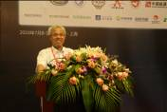 | 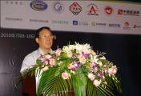 | 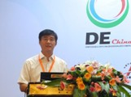
Zhang Yuqing - Director of the Oil & Gas Department of National Energy Administration | Lu Yanchang - Director of China Electrical Machinery  Engineering Society | Qin Hua - Chairman of Southern Power Grid Integrated Energy Company
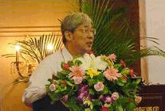 | 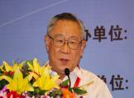 | 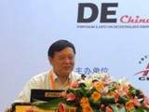
Xu Jianzhong - Academician, Chinese Academy of Science | Hua Ben / Director of South China University of Science & Technology | Zhou Xiaoxin - Academician,  Chinese Academy of Science

Participating and Registration
Company Name
Address |  |  | Zip Code
Contact Name |  |  | Position
Mobile phone |  |  | E-mail
Invoice Name
Invoice Content | □Technical Service Fee □Consulting Services Fee □Information Service Fee □Service Fee □ Seminar Service Fee
Participant Name | Department | Position | Mobile phone  (Required) | E-mail |  | Postal Box
Participation Fees |  | Standards for Charge (including seminar-related materials, coffee-break, dining, and visiting)CNY 6500/person or US $ 1200/person  CNY 5500/person or US $ 1000/person favorable to group (min. 5 people including 5)  Total _ people of _ entity participate, total fees: ((￥：______Yuan)
Self-Pay Accommodation |  | The organizing committee has reserved part of the rooms for participants in the following hotels and the participants shall enjoy special discounts for staying in the hotels.  The number of the reserved rooms is limited. Should you want to book room, please contact with the hotel before August 1, 2013 and indicate that you are participating in the “The Ninth International Seminar & Exhibition of China Distributed Energy” organized by China Energy Net.
Mode of Payment | Bank Remittance | Full name of the payee: China Energy Net Consulting Co., Ltd  Bank: Beijing Baiyun Road Branch of Industrial and Commercial Bank of China (ICBC Baiyun Road Branch)  Bank Account: 020 002 001 920 090 0532
Inquiries |  | Contact: Lang Yunhua  Inquiry Phone: 010-51915030-608  Fax: 010-51915237  Email: yunhua@china5e.com  Seminar Website: www.china5e.com

